UNIT – III
- Define an autoencoder. List the main components of an autoencoder architecture. applications of autoencoders.
An autoencoder is an unsupervised neural network used to learn efficient representations of data by compressing the input into a lower-dimensional form and then reconstructing it as accurately as possible.Its goal is to minimize reconstruction error between the input and the output.
Main Components of an Autoencoder Architecture
- Encoder
  - Compresses the input data into a latent (hidden) representation
  - Reduces dimensionality
- Latent Space (Code/Bottleneck)
  - Compact representation capturing important features of the input
  - Forces the network to learn meaningful patterns
- Decoder
  - Reconstructs the original input from the latent representation
  - Attempts to produce output close to the original input
- Reconstruction Loss Function
  - Measures difference between input and output
  - Examples: Mean Squared Error (MSE), Binary Cross-Entropy
Applications of Autoencoders
- Dimensionality reduction
- Feature extraction
- Data denoising (Denoising Autoencoders)
- Anomaly detection
- Image compression

- Define types of autoencoder like sparse autoencoder, denoising autoencoder, undercomplete autoencoders, regularized autoencoder, stochastic autoencoder, contractive encoder?
1. Undercomplete Autoencoder
An undercomplete autoencoder has a latent space smaller than the input dimension, forcing the network to learn compact and meaningful representations rather than copying the input.
2. Sparse Autoencoder
A sparse autoencoder applies a sparsity constraint like L1 Regularization so that only a few neurons in the hidden layer are active at a time, even if the latent space is large.
This helps in learning important features
3. Denoising Autoencoder
A denoising autoencoder is trained to reconstruct the original clean input from a corrupted or noisy version of the input, making the model robust to noise.
4. Regularized Autoencoder
A regularized autoencoder adds penalty terms (such as L1, L2 regularization or sparsity constraints) to the loss function to prevent overfitting and encourage better feature learning.
5. Stochastic Autoencoder
A stochastic autoencoder introduces randomness in the encoding process, usually by sampling from a probability distribution, which helps in learning smooth and generalized representations.
(Variational Autoencoder is a common example.)
6. Contractive Autoencoder
A contractive autoencoder adds a penalty on the sensitivity of the encoder to small input changes, encouraging the model to learn robust and invariant features.

- What is a Generative Adversarial Network (GAN)? GAN architecture and its objective function.
A Generative Adversarial Network (GAN) is a deep generative model consisting of two neural networks that compete with each other to generate data that resembles real data.
It is an unsupervised learning framework proposed by Ian Goodfellow (2014).
GAN Architecture
GAN consists of two networks:
1. Generator (G)
- Takes random noise (z) as input
- Generates synthetic (fake) data
- Goal: fool the discriminator into believing generated data is real
2. Discriminator (D)
- Takes real and generated data as input
- Outputs probability (0–1) indicating whether data is real or fake
- Goal: correctly classify real vs fake data
📌 Both networks are trained simultaneously in a minimax game.
Objective Function of GAN
GAN training is formulated as a minimax optimization problem:
$$\underset{G}{min⁡}\underset{D}{max⁡}V(D,G)=E_{x∼p_{data}(x)}[log⁡D(x)]+E_{z∼p_{z}(z)}[log⁡(1-D(G(z)))]$$
Interpretation
- Discriminator maximizes the probability of:
  - Correctly identifying real data
  - Rejecting fake data
- Generator minimizes this function by:
  - Generating data that fools the discriminator

- Discuss the challenges in training GANs such as mode collapse and oscillation loss. How to overcome them?
Model Collapse –
generator produces very limited varieties of samples, even though the real data has many modes.
• Generator finds a small set of outputs that successfully fool the discriminator
• Discriminator fails to penalize lack of diversity
Overcome Mode Collapse
- Mini-batch discrimination
- Feature matching
- Unrolled GANs
- Wasserstein GAN (WGAN)
- Adding noise to discriminator inputs

Oscillation Loss –
Oscillation occurs when GAN training does not converge and generator and discriminator keep overpowering each other, causing fluctuating losses.
Loss values do not stabilize even after many epochs.
How to Overcome Oscillation
- Careful learning rate tuning
- Training discriminator and generator alternately
- Label smoothing
- Gradient penalty (WGAN-GP)
- Use of batch normalization

- Explain how Wasserstein GAN improves GAN training stability.
Use of Wasserstein Distance to Provides a continuous and smooth loss function instead of Jensen–Shannon divergence. Stable training. Real valued score for discriminator instead of probability. No sigmoid in the output. No model Collapse. Higher diversity for the output.

- Describe CycleGAN architecture and its applications.
Generative model used for unpaired image-to-image translation between two domains $X$and $Y$.
CycleGAN consists of two generators and two discriminators:
G1 : X-> Y G2: Y-> X
• $D_{Y}$: distinguishes real Y images from fake Y images
• $D_{X}$: distinguishes real X images from fake X images

UNIT – IV
- Define novelty detection. Example
Novelty Detection is a data analysis technique used to identify new, previously unseen patterns that differ significantly from the normal or known data.
Unlike errors or noise, novel patterns are meaningful and useful.
Example – Spending is history is considered normal data. If new pattern is found in Frequent internal transactions, it is treated as novalty
Used in – fraud detection, error detection, and outlier detection.

- What is outlier detection? Example? Explain different methods of outlier detection? 4 Applications?
Outlier detection is the process of identifying data objects that significantly deviate from the rest of the dataset and may indicate errors, noise, or rare events.
Applications - Fraud detection, Network intrusion detection, Medical diagnosis, Data cleaning.
Methods –
- Z-Score - It assumes the data follows a normal distribution. A point with a very high or Z-score (typically |Z| > 3) is flagged as an outlier because it lies in the extreme tails of the distribution.
- IQR Method - Any value that falls below Q1 − 1.5 × IQR or above Q3 + 1.5 × IQR is considered an outlier. IQR = Q3-Q1
- Local Outlier Factor (LOF) – Density- based approach that compares local density of data point to its neighbours. lower is flagged as an outlier.
- Clustering Based –local point does not have any nearby cluster that is core point. Ex- DBSCAN.

- Differentiate between novelty detection and outlier detection.
Feature | Novelty Detection | Outlier Detection
Purpose | Detects new patterns | Detects abnormal points
Nature | Meaningful and useful | Often noise or error
Training Data | Only normal data | Uses full dataset
Output | New valid behavior | Rare or suspicious data
Example | New customer behavior | Data entry mistake

- What is density estimation?
Density Estimation is the process of estimating the probability distribution of data points in a dataset. It helps understand how data is distributed in the feature space.
Types:
- Parametric (e.g., Gaussian distribution)
- Non-parametric (e.g., histograms, kernel density estimation)

- Define histogram-based density estimation.
Non-parametric technique where data is divided into bins, and density is estimated based on the number of data points in each bin.

- Describe kernel density estimation (KDE). How do they help in density estimation with suitable diagram.
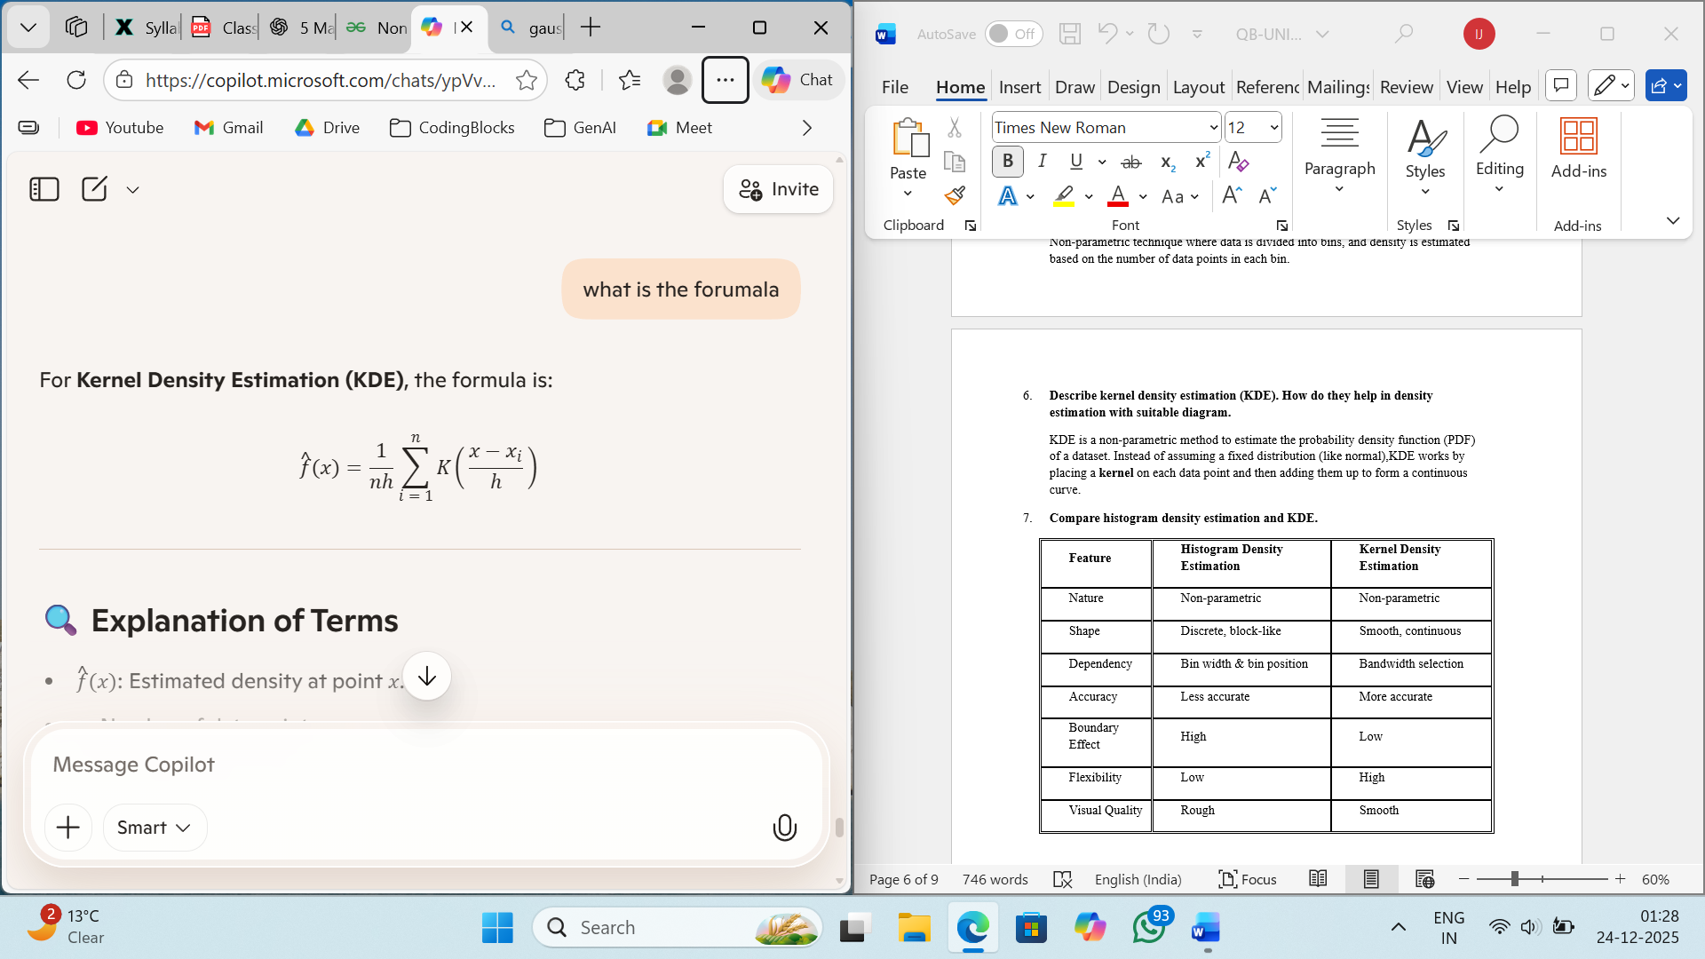
KDE is a non-parametric method to estimate the probability density function (PDF) of a dataset. Instead of assuming a fixed distribution (like normal),KDE works by placing a kernel on each data point and then adding them up to form a continuous curve.

Smaller Bandwidth – Overfitting , sharp peak
Larger Bandwidth – Underfitting , smooth peak

- Compare histogram density estimation and KDE.
Feature | Histogram Density Estimation | Kernel Density Estimation
Nature | Non-parametric | Non-parametric
Shape | Discrete, block-like | Smooth, continuous
Dependency | Bin width & bin position | Bandwidth selection
Accuracy | Less accurate | More accurate
Boundary Effect | High | Low
Flexibility | Low | High
Visual Quality | Rough | Smooth

- What is a Kohonen Self-Organizing Map (SOM)? Explain the architecture and training algorithm? Explain the role of neighbourhood functions? Limitations?
SOM is an unsupervised neural network used for clustering and dimensionality reduction which effectively maps high-dimensional data to a lower-dimensional grid enabling easier interpretation and visualization of complex datasets while preserving topology.
It consists of two primary layers:
- Input Layer: Represents the features of the data.
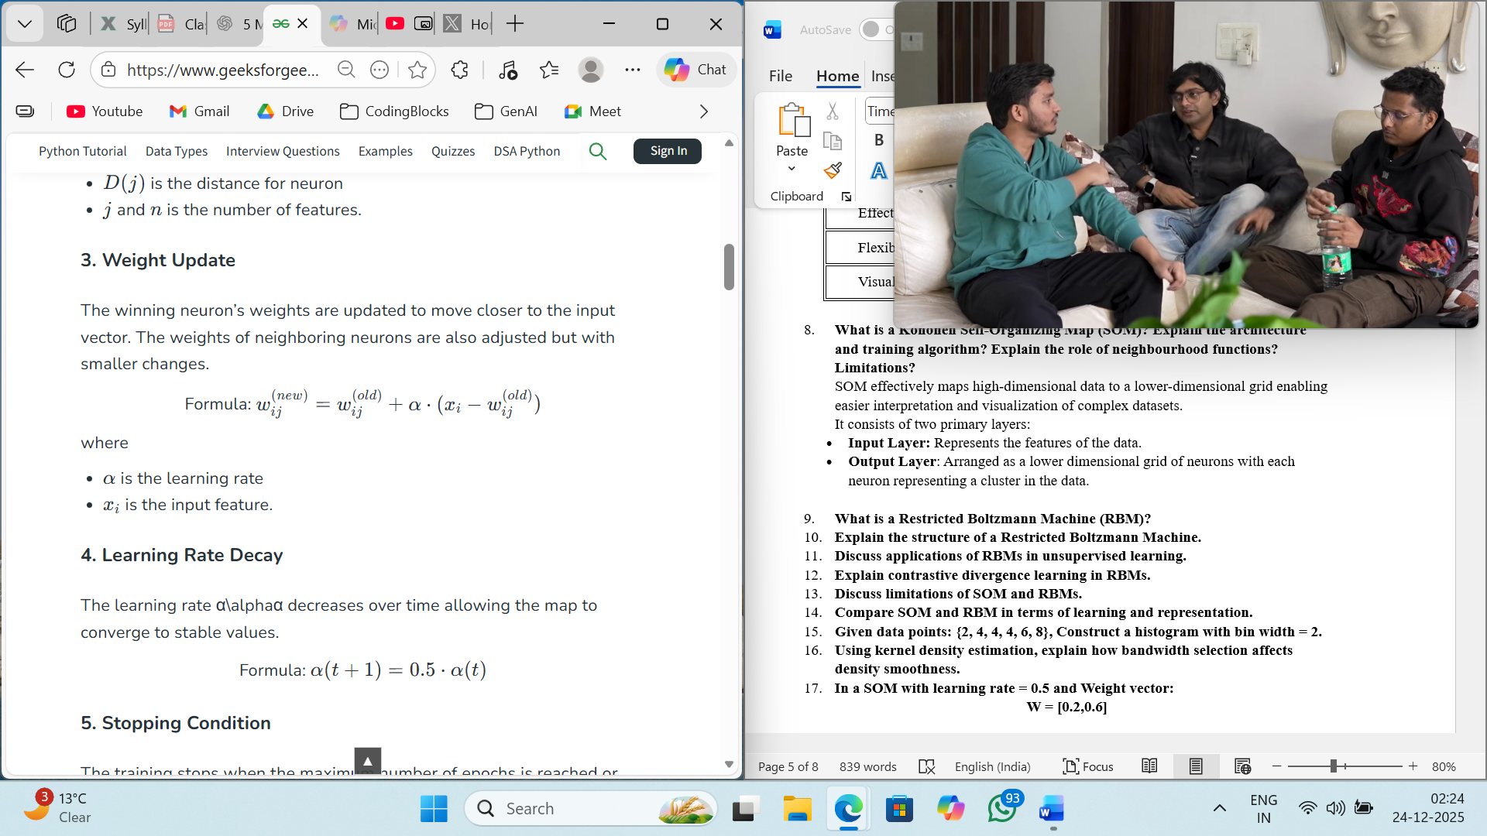
- Output Layer: Arranged as a lower dimensional grid of neurons with each neuron has a weight vector of the same dimension as the input.
During training, for each input vector, the Best Matching Unit (BMU) is selected based on minimum Euclidean distance.
Alpha reduces by half after every T+1, helping convergence to stable values. Training stops when number of epochs is reached or when weights converge.

The neighbourhood function controls how much nearby neurons are updated.
It preserves topological structure, ensures smooth mapping, and helps neurons learn similar patterns.

Limitations –
  - Depends on initial weights
  - Choice of map size is difficult
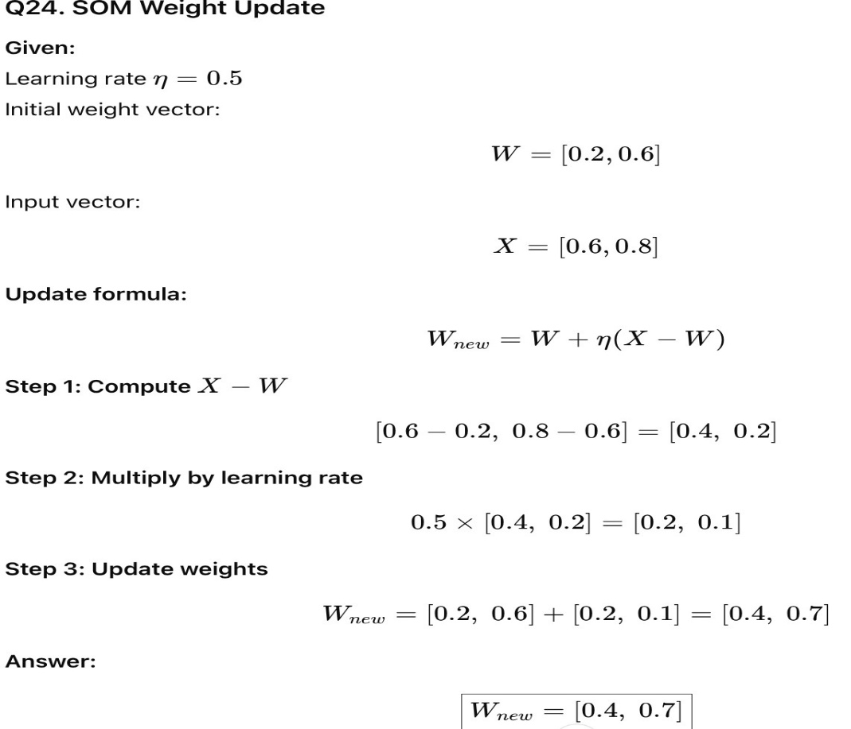
  - Computationally expensive.

- What is a Restricted Boltzmann Machine (RBM)? Explain the structure. Discuss applications. Explain contrastive divergence learning in RBMs. Discuss limitations
A Restricted Boltzmann Machine (RBM) is a stochastic, unsupervised generative neural network used to learn probability distributions over input data.
It is called restricted because there are no connections between neurons within the same layer. Energy-based model
Structure of RBM
RBM consists of two layers:
- Visible Layer (v):
Represents observed input data
- Hidden Layer (h):
Learns latent features from input

Applications of RBM
- Feature learning and dimensionality reduction
- Collaborative filtering (e.g., recommendation systems)
- Image and speech recognition
- Pre-training of deep neural networks (Deep Belief Networks)

Limitations of RBM
- Difficult to train for large datasets
- Approximate learning may not converge to true distribution
- Sensitive to hyperparameter tuning
- Limited representational power compared to deep models

Contrastive Divergence (CD) Learning in RBMs
Contrastive Divergence is an efficient approximation algorithm used to train RBMs.
Steps:
- Positive Phase:
  - Visible units are clamped to training data
  - Hidden unit activations are computed
- Negative Phase:
  - Reconstruct visible units from hidden units
  - Recompute hidden activations from reconstructed data
- Weight Update:
  - Weights are updated using the difference between positive and negative phase correlations
$$Δw=η\left(⟨vh⟩_{data}-⟨vh⟩_{model}\right)$$

